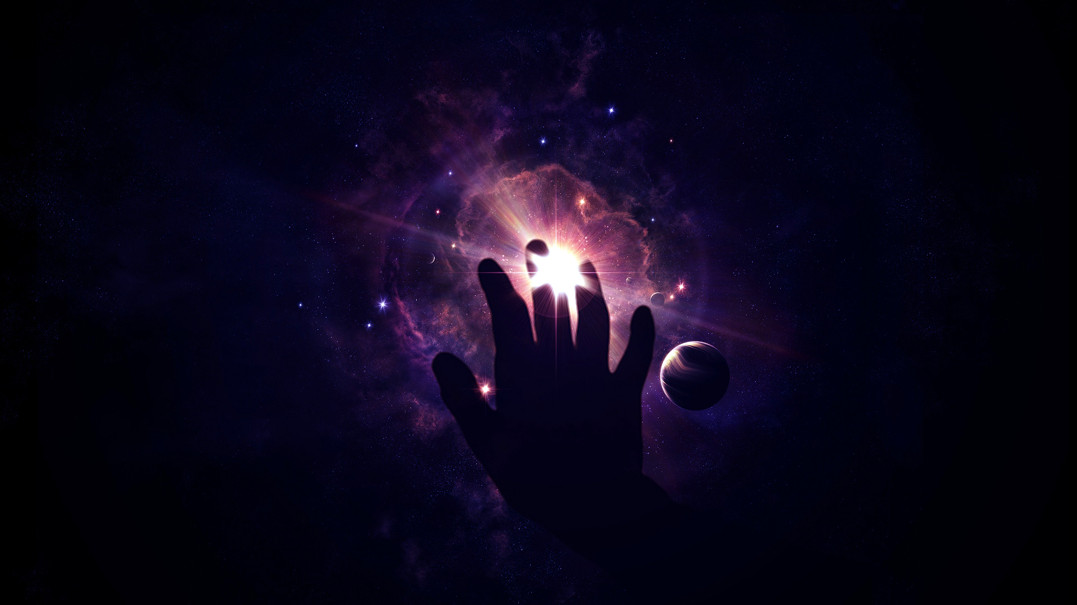

The Universe
Look up in the sky. Everything you see, from the brightest star to the faintest galaxy, is part of the same universe. We can see things in the universe over fifteen billion light years away. A light-year is the distance light travels in one year - over 9.4 trillion (9,400,000,000,000) kilometers! That means we can see things that are over 142,000,000,000,000,000,000,000 kilometers away. The universe is a big place!

The Expanding Universe
In fact, the universe is getting even bigger. Astronomers believe that the universe is expanding - that all points in the universe are getting farther apart all the time. It's not that stars and galaxies are getting bigger; rather, the space between all objects is expanding with time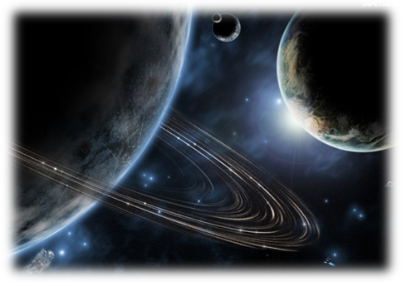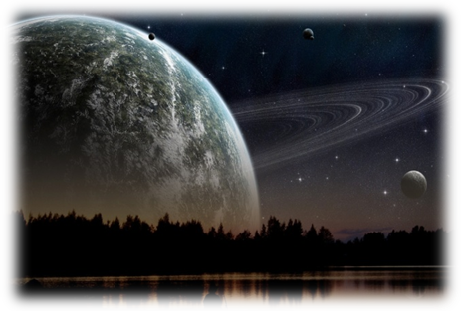. If the universe is expanding, then at some time in the past, it must have started from a single point. Astronomers call this point "the big bang" - the universe began when it was compressed into a single point, very dense and very hot.

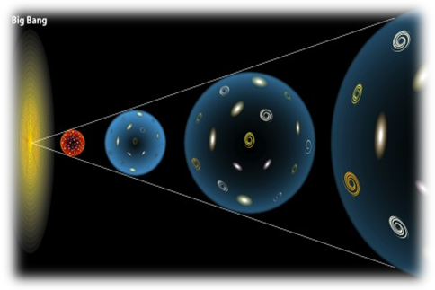How do we know the universe is expanding?

Well, for a long time, we didn't know. Although the universe is expanding all around us, the expansion happens over such a large scale that we never notice it on Earth. In fact, it was only 80 years ago that anyone realized the universe was expanding. The expansion of the universe was discovered in 1929, when American astronomer Edwin Hubble brought together many scientists' work.

